v0.2
Java Performance Troubleshooting & Tuning Guide
By Ravi Sharda

Table of Contents

1. Introduction 5
1.1. Overview 5
1.1.1. Target Audience 5
1.1.2. Guide to this Document 5
1.1.3. Feedback and Suggestions 5
1.2. Background 5
1.2.1. What is Performance? 5
1.2.2. What affects an Application’s Performance? 6
1.3. Performance Tuning Steps 7
1.3.1. When a Performance Problem Triggers Tuning 7
1.3.2. When Load & Stress Testing Triggers Tuning 9
2. Application Tuning 11
2.1. Hangs and Looping Processes 11
2.1.1. Diagnosing a Hung or Looping Process 11
2.2. Garbage Collection (GC) 13
2.2.1. Hotspot vs. Older JVMs 13
2.2.2. Generational Heaps 101 13
2.2.3. Execution Modes 15
2.2.4. Diagnosing GC Bottlenecks 17
2.2.5. Resolving GC Bottlenecks 21
2.3. OutOfMemoryError 23
2.3.1. What is OutOfMemoryError 23
2.3.2. Decoding the Detail Message 24
2.3.3. Diagnosing Leaks in Java Language Code 25
2.3.4. Resolving OutOfMemoryErrors 26
2.4. Memory leaks 27
2.4.1. Reasons for Memory Leaks 27
2.4.2. Determining if an application has memory leak 28
2.5. Weblogic Application Server (WLS) 28
2.5.1. Understanding WLS JDBC Connection Pool Options 28
2.5.2. Understanding Other Key WLS Tuning Factors 30
2.5.3. Tools to Monitor WLS Performance 31
2.5.4. Resolving Bottlenecks 32
3. System (OS), Network and Database Tuning 34
3.1. System memory 34
3.1.1. Understanding System Memory Bottlenecks 34
3.1.2. Tools to Monitor System Memory 34
3.1.3. Resolving System Memory Bottlenecks 37
3.2. CPU 37
3.2.1. Understanding CPU Bottlenecks 37
3.2.2. Tools to Monitor CPU 38
3.2.3. Resolving CPU Bottlenecks 41
3.3. Disk & Disk I/O 41
3.3.1. Understanding File Descriptor Bottlenecks 42
3.3.2. Understanding Other Disk Bottlenecks 42
3.3.3. Tools to Monitor Disk Bottlenecks 42
3.3.4. Performance Tuning Options 49
3.4. Network Performance 49
3.4.1. Understanding Network Bandwidth Bottlenecks 49
3.4.2. Latency 50
3.4.3. Other Network Bottlenecks 50
3.4.4. DNS Lookups 51
3.4.5. Tools to Diagnose Network Performance 51
3.5. Database 52
3.5.1. Oracle Specific Tuning 52
4. Analysis Tools & Utilities 54
4.1. Java Monitoring Tools 54
4.1.1. HPROF 54
4.2. Unix Monitoring & Tuning 54
4.2.1. vmstat Command (Display virtual memory statistics) 54
4.2.2. netstat Command (Displays network statistics) 55
4.3. Linux Performance Monitoring 55
4.3.1. Free Command 56
4.4. General Tips 57
4.4.1. How to see the complete syntax of a command? 57
4.4.2. Java Specific command help 57
4.4.3. Where do I find detailed help on the command? 58
4.4.4. How do I redirect standard out and error of a JVM to a file? 58
5. References 59

Version History

Document Version | Date | Description | Author | Approver
0.1 | 4/13/09 | Created the initial draft version. | Ravi Sharda
0.2 | Until 5/10/09 | Created sections on various aspects and update with detailed information. | Ravi Sharda

Introduction
"More computing sins are committed in the name of efficiency (without necessarily achieving it) than for any other single reason-including blind stupidity." – W. A. Wulf

Overview
This document is a guide to help troubleshoot performance problems that may arise in Java applications and to help resolve those problems. It provides a description of tools, command line options and other items that can be used when analyzing the problem. It also provides some guidance on general strategies, techniques one could use to resolve such problems.

Target Audience
This document is written for development, testing and operations maintenance team members who may have a need to monitor and tune an application’s performance.
The document assumes that readers have high-level understanding of Java Virtual Machine (JVM) and operating systems concepts.

Guide to this Document
<TODO>
For related information about administering and tuning Java server applications, see References.

Feedback and Suggestions
Readers are encouraged to provide feedback and suggestions to improve this document by sending a mail to the document owner (ravi.sharda@qwest.com).

Background
Critical to optimizing an application for high performance is establishing what it actually means and what really affects an application’s performance. This section deals with these concerns.

What is Performance?
Performance, as a software quality attribute, refers to the responsiveness of the system: a) Either, the time required in responding to specific events, or b) The number of events processed in a given interval of time.
Performance qualities can be expressed using the following characteristics:
- Latency: Latency refers to a time interval during which the response to an event must be executed.
  - How long does it take to respond to a specific event?
  - For example, response time for a transaction (average, maximum)
- Throughput: Throughput refers to the number of event responses that have been completed over a given observation interval.
  - How many events can be responded to over a given interval of time?
  - For example, transactions per second.
- Capacity: This is a measure of the amount of work a system can perform. Capacity is often defined in terms of throughput.
  - How much demand can be placed on the system while continuing to meet latency and throughput requirements?
  - For example, the number of customers or transactions the system can accommodate.
- Resource utilization: This represents the percentage of time the resource (such as CPU, memory, I/O device, backplane bus, network, communications) is busy.
- Modes: It is not uncommon for systems to have different sets of requirements for different phases of execution. For example, an avionics system could have different requirements for the take-off phase than for the cruising phase. We refer to these different phases as modes. A mode can be characterized by the state of the demand being placed on the system and the state of the system (that is, the configuration of resources used to satisfy the demand).
Two commonly encountered modes are reduced capacity and overload. A system might have to operate with reduced capacity if resources cease to function properly. A system might have to sacrifice timing requirements of less important events during periods of overload.
- What is the acceptable mode of operation when the system has been degraded in some manner? How can the demand and resources change over time? What happens when system capacity is exceeded and not all events can be responded to in a timely manner?

What affects an Application’s Performance?
Broadly, the overall performance of a Java application depends on four factors:
- The design of the application. The design of an application (for example, its data structures and logic) and how it interacts with all layers of the system can affect performance in a big way. Although it may seem rather obvious, but all too often this is ignored or not well-understood.
For example,
- Does the collection you chose really need to keep data in a sorted state? If not, choosing such a collection could be a big performance loss.
- Is the class you are designing accessed remotely? If so, then putting lots of little methods on the interface is probably a bad choice.
- The speed at which the VM executes the Java byte-codes. The virtual machine is responsible for byte-code execution, storage allocation, thread synchronization, etc.
- The speed at which the libraries that perform basic functional tasks execute (in native code). Running with the virtual machine are native code libraries that handle input and output through the operating system.
- The type and quantity of underlying hardware and operating system. Every node and link in the application and its environment (databases, application server, JVM, network, hardware, OS) is a potential bottleneck. System resources such as the following constrain the application’s performance:
  - CPU speed and availability
  - System memory
  - Disk and network input/output (I/O)

Performance Tuning Steps

When a Performance Problem Triggers Tuning
Typical comments that trigger performance tuning are: “The app is hung!”, “The system is very slow”, “The app is not responding”, etc.
So where do we start?
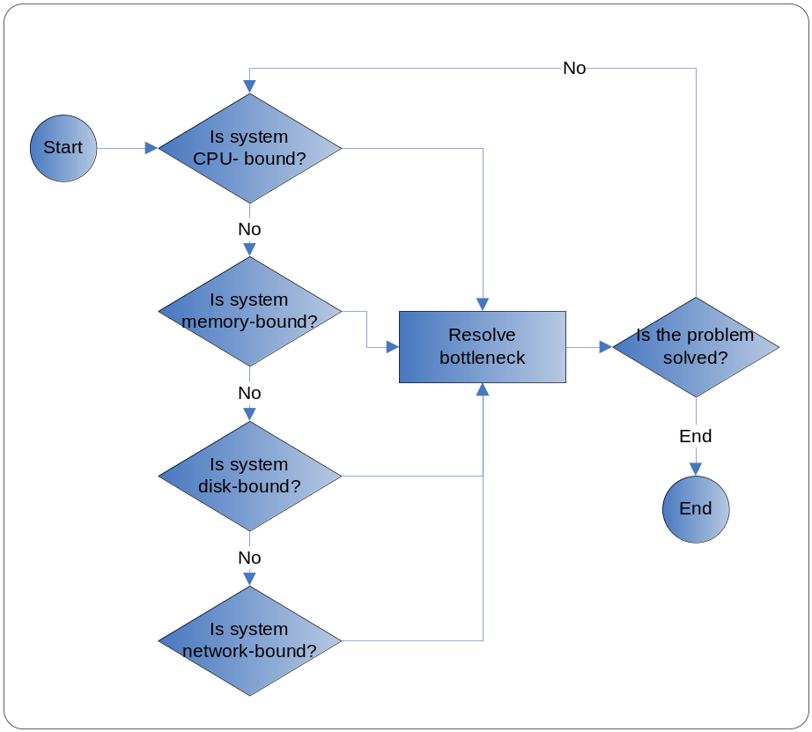

As illustrated in the above diagram, the major steps in any performance tuning effort are as follows:
- Determine what the bottleneck is.
  - Determine if CPU(s) is/are busy and track down which process is using the CPU cycles.
If the application is CPU bound, one has to focus the efforts on the code, looking for bottlenecks such as
- In-efficient algorithms,
- Too many short-lived objects (object creation and garbage collection are CPU intensive operations), and
- Other problems.
  - If CPUs seem fine (typically under 85% or so), then one should check if memory is running out.
If the application is hitting system memory limits (is memory-bound), the system may be paging sessions to disks – which is a performance killer.
In this case, the problem may be caused by too many objects, or even just a few large objects, being erroneously held in memory; by too many large arrays being allocated (frequently used in buffered applications); or by the design of the application, which may need to be reexamined to reduce its running memory footprint.
  - If memory is not the main problem, then one should check if disk I/O is high. One should find out which process or thread is writing to and from the disk.
  - If disk I/O us not the main problem check if network bandwidth or latency is the problem.
- Resolve the bottleneck, or in other words tune the application or system.
  - Tune the application first – primarily because it is simplest or easiest to do so.
  - Constantly monitor the entire system with any monitoring tools available. Monitoring utilities include perfmeter (Unix CPU), vmstat (Unix CPU, RAM and disks), iostat (Unix disks), netstat (network I/O), ping (network latency) and nslookup (DNS lookup and routing). The article introduces several of them.
    - Keep monitoring records to get a background usage pattern.
    - Watch for levels of paging that decrease system performance.
    - Watch for low CPU activity coupled with high disk activity and delayed responses. This may indicate an I/O problem.
    - Monitor for retransmissions of data packets.
    - Ensure the CPU runnable queue does not get too large.
    - Aim for average CPU utilization to be not more than 75%.
  - Tune the application server and DB.
  - Tune the Java runtime.
  - Tune the operating system and network.
- Check whether the performance is acceptable.
- Repeat step 1 if performance is still not acceptable.
It is important to note that once one has tuned the app’s first bottleneck, one may typically find another bottleneck to solve, and therefore one may require several tuning iterations. Therefore, it is important that one spends time only to solve the main bottlenecks at any one time rather than fix everything that one sees.

When Load & Stress Testing Triggers Tuning
No application can handle an unlimited number of requests. The trick is to anticipate the likely user demand and ensure that the application can gracefully scale up to the demand while maintaining acceptable levels of speed.
It is important to establish performance requirements for your application. Using stress testing techniques, one can validate that the application actually meets those requirements.
Sample metrics are shown in the following table:

Characteristic/Concern | Metric
Latency (User View) | Response time in seconds to user requests for the conditions described below.
Throughput & capacity (System View) | Throughput – Number of transactions per minute  Capacity - Number of concurrent users that may access the application
Resource Utilization (System View) | CPU utilization at different load levels (min, max, average).  Memory consumption at different load levels.

Stress testing is a common process for determining the scalability of an application. It is aimed at determining under what conditions an application’s performance becomes unacceptable.
The simplest way to stress test an application while varying the inputs such as number of clients, size of requests, frequency of requests, mix of requests, and so on and plot how the performance varies. This activity is also called load testing, though load testing usually describes a specific type of stress testing - increasing the number of users to stress test your application.
Stress testing helps identify the general areas of the application that require optimization. With this information, steps described in section 1.4.1 can be used to identify and resolve the bottlenecks.

Application Tuning

Hangs and Looping Processes
Performance issues often arise due to hangs or looping processes. A hang may arise for many reasons. Some of them include: a deadlock in application code, a thread going into an infinite loop in the application code, API/library code, consumed Webservice not returning etc.

Diagnosing a Hung or Looping Process
- Thread dumps. If a VM process appears to be hanging or looping then the first step is to try and get a thread dump. The output of the thread dump will often make it clear which threads are looping and often also provide a direction on where (and possibly why) the thread(s) is/are looping.
If the application console (standard in/out) is available, then pressing the Ctrl-\ or Ctrl-Break keys – depending on the platform, will result in the JVM printing a thread dump on the standard out.
On Solaris and Linux a thread dump can also be obtained by sending a SIGQUIT to the process (kill -QUIT <pid>) or invoking kill -3 (kill -3 <pid>. In this case the thread dump will be printed to the standard output of the target process (which may be directed to a file depending on how it was started – for example nohup.out or a server console log file in weblogic).
Looking at the thread dump, if one finds conclusive evidence that most threads are waiting at the same point in the code, one could easily deduce that there is a problem with that section of the code or service invoked by the application at that point.
After printing the thread dump, the Hotspot VM executes a deadlock detection algorithm. If a deadlock is detected, it will be printed along with the stack trace of all the threads involved in the deadlock. If the deadlock detection algorithm detects a deadlock then it is necessary to examine the output in more detail so that the deadlock can be understood and resolved.
Sample output:
Found one Java-level deadlock:
=============================
"AWT-EventQueue-0":
waiting to lock monitor 0x000ffbf8 (object 0xf0c30560, a
java.awt.Component$AWTTreeLock),
which is held by "main"
"main":
waiting to lock monitor 0x000ffe38 (object 0xf0c41ec8, a java.util.Vector),
which is held by "AWT-EventQueue-0"
Java stack information for the threads listed above:
===================================================
"AWT-EventQueue-0":
at java.awt.Container.removeNotify(Container.java:2503)
- waiting to lock <0xf0c30560> (a java.awt.Component$AWTTreeLock)
…
Found 1 deadlock.

In J2SE 5.0 deadlock detection works only with locks that are obtained using the synchronized keyword. This means that deadlocks that arise through the use of the java.util.concurrency (such as semaphores, latches, etc.) package are not detected.
- Jstack utility (Since Java 5.0). Sometimes the process may be running in the background and the VM standard out may be redirected to a unknown file. In that case jstack (available on Solaris and Linux versions of JDK 5.0) command on Solaris/Linux can be used. The utility attaches to the specified process (or core file) and prints the stack traces of all threads that are attached to the virtual machine (this includes Java threads and VM internal threads).
Sample output of jstack is:
>jstack 7034
Debugger attached successfully.
Server compiler detected.
JVM version is 1.5.0-rc-b63
Thread t@44: (state = BLOCKED)
- java.lang.Object.wait(long) (Interpreted frame)
- java.lang.Object.wait(long) (Interpreted frame)
- org.apache.tomcat.util.threads.ThreadPool$MonitorRunnable.run() @bci=8,
line=549 (Interpreted frame)
- java.lang.Thread.run() @bci=11, line=595 (Interpreted frame)
Thread t@43: (state = IN_NATIVE)
- java.net.PlainSocketImpl.socketAccept(java.net.SocketImpl) (Interpreted frame)
- java.net.PlainSocketImpl.socketAccept(java.net.SocketImpl) (Interpreted frame)
- java.net.PlainSocketImpl.accept(java.net.SocketImpl) @bci=7, line=384
(Interpreted frame)
- java.net.ServerSocket.implAccept(java.net.Socket) @bci=50, line=450
(Interpreted frame)
- java.net.ServerSocket.accept() @
For more information on jstack, refer to its manual page available at: http://java.sun.com/j2se/1.5.0/docs/tooldocs/share/jstack.html
In this case, also examine each of the threads in BLOCKED state. The top frame can sometimes indicate why the thread is blocked (Object.wait or Thread.sleep for example), and the rest of the stack should give an indication as to what the thread is doing. Note that threads in IN_NATIVE state may also be blocked.

Garbage Collection (GC)
Garbage collection (GC) is the VM’s process of freeing up unused Java objects in the heap.
It is common knowledge that Java shields the developer from the complexity of memory allocation and GC.
However, if garbage collection becomes the main bottleneck, resolving the bottleneck requires one to understand some aspects of this complex beast. Sub-sections 2.1.1, 2.1.2 cover such aspects. Other sub-sections under this provide information on the tools to diagnose and tune the GC.

GC Basics

Hotspot vs. Older JVMs
Prior to Hotspot, most JVMs had three main problems:

All objects were scanned during GC. As the number of objects increased, so did this GC’s performance time.
- Partially accurate algorithms were conservative when reclaiming memory.
- The GC used handles to refer indirectly to objects in memory. The inability to relocate objects cause significant memory fragmentation and prevented the use of more sophisticated GC algorithms.
JVM 1.2.2 introduced exact GC – which was further improved and named as generational GC. Java Hotspot VM 1.3.1’s GC is guarantees the following:
  - You can reliably reclaim all inaccessible objects' memory
  - You can relocate all objects to compact memory, eliminating object memory fragmentation
While naive garbage collectors – prior to generational collectors, examine every live object in the heap, generational collection exploits several empirically observed properties of most applications to minimize the work required to reclaim unused ("garbage") objects [SUN_TUNING].
Beginning with the J2SE 1.2, the virtual machine incorporated a number of different garbage collection algorithms that are combined using generational collection.

Generational Heaps 101
As mentioned earlier, the HotSpot JVM manages heap space in generations - that is, memory pools for new and old objects.
The generational garbage collector (GGC) exploits the following two major observations (collectively known as the weak “generational hypothesis”) found in most applications:
- High “infant mortality” – i.e., most objects can be reclaimed shortly after being allocated or in other words are “short-lived”.
Iterator objects, for example, are often alive for the duration of a single loop.
- Also, there are few references between long-lived objects and short-lived objects.
To take advantage of the weak generational hypothesis described above, the Hotspot VM splits the JVM into two areas as illustrated in Figure 1.

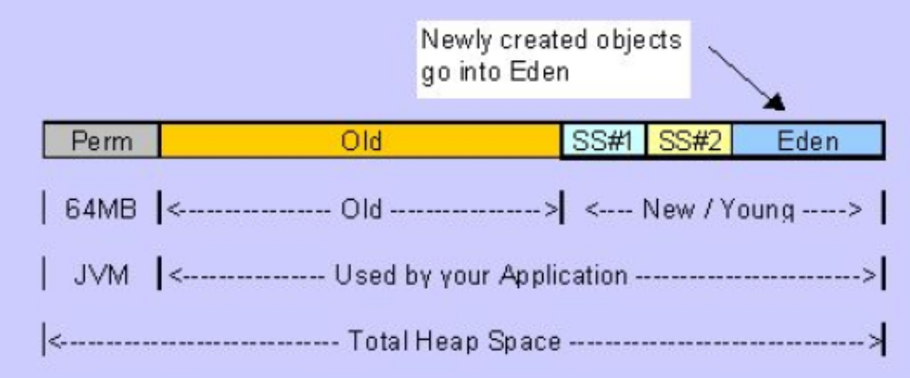
Figure 1 Hotspot Generations

The memory space is divided into the following sections [PRINTEZIS_04]:
- Young Generation. Most newly allocated objects are allocated in the young generation. This space is typically small and collected frequently. Since most objects in it are expected to die quickly, the number of objects that survive a young generation collection (also referred to as a “minor collection”) is expected to be low.
In general, minor collections are very efficient because they concentrate on a heap space that is usually small and is likely to contain a lot of garbage objects. Therefore, the pauses during minor collections are shorter.
- Old Generation. Objects that are longer-lived are eventually promoted, or tenured, to the old generation. This generation is typically larger than the young generation and its occupancy grows more slowly. As a result, old generation collections (also referred to as “major collections”) are infrequent, but when they do occur they are quite lengthy.
- Permanent Generation.
Young Generation. The young generation is split into three separate areas:
- Eden: This is where most new objects are allocated (not all, as large objects may be allocated directly into the old generation). The Eden is always empty after a minor collection.
- The two Survivor spaces: These hold objects that have survived at least one minor collection but have been given another chance to die before being promoted to the old generation. At any given time, one of the survivor spaces holds such objects, while the other remains unused until the next collection.
When the young space gets overcrowded, a minor GC is done. The GGC runs through every object in the “eden” and the occupied “survivor” space to determine which objects are still alive – or in other words which objects still have external references to themselves. A very simple copy algorithm is then used that copies the live objects to the free “survivor” space.
Old/Tenured Space. As objects reach a certain age - dynamically defined by Hotspot, or as the survivor space gets too small, the still alive objects are copied to the tenured space. Note that very few objects typically live long enough to go to tenured space.
In the tenured space, the laws are different. Whenever more memory is needed, a major collection is done with the help of the Mark-Sweep-Compact algorithm. It's greedier than the copy algorithm. The GC will run through all the objects in the heap, mark the candidates for memory reclaiming, and run through the heap again to compact remaining objects and avoid memory fragmentation. At the end of this cycle, all living objects exist side-by-side in the tenured space.
Unlike a minor collection, running a major collection usually stops the execution of the whole application (except in Incremental GCs). So a good optimization trick is to reduce the burden of the Mark-Sweep-Compact algorithm.
If after a major collection, objects cannot be freed up enough to accommodate newly created objects, and there is no scope to expand the heap, an Out-Of-Memory exception is thrown and the JVM is crashed.
Permanent Generation. This holds objects that the JVM itself creates for caching or other purposes, such as class and method objects, code, reflection information, etc. If this space is full, a full garbage collection takes place. If the major GC cannot clean up old unreferenced classes and there is no room left to expand this generation, an Out of Memory Error is thrown.
The next sub-section Execution Modes describes the algorithms or execution modes that one can choose from for the garbage collector.
A major advantage of generational garbage collection is that each generation can be managed by the garbage collection algorithm that is most appropriate for its characteristics [PRINTEZIS_04]:
- A fast GC usually manages the young generation, as minor collections are very frequent. This GC might be a little space wasteful, but since the young generation typically is a small portion of the heap, this is not a big problem.
- On the other hand, a GC that is space efficient usually manages the old generation, as the old generation takes up most of the heap. This GC might not be quite as fast, but because major collections are infrequent, it doesn't have a big performance impact.

Execution Modes
To change the behavior of the GC itself, one can choose among the different execution modes:
- Serial. With serial collection, only one thing happens at a time. For example, even when multiple CPUs are available, only one is utilized to perform the collection. The serial collector is usually adequate for most "small" applications (those requiring heaps of up to approximately 100MB on modern processors). The other collectors have additional overhead and/or complexity which is the price for specialized behavior. If the application doesn't need the specialized behavior of an alternate collector, use the serial collector.

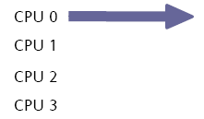
Figure 2 Serial - One thing happens at a time

- Parallel. When parallel collection is used, the task of garbage collection is split into parts and those subparts are executed simultaneously, on different CPUs. The simultaneous operation enables the collection to be done more quickly, at the expense of some additional complexity and potential fragmentation.
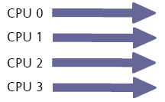
Figure 3 Parallel - Single task (split into multipl parts) happen at a time

- Concurrent. When stop-the-world garbage collection is performed, execution of the application is completely suspended during the collection.
Alternatively, one or more garbage collection tasks can be executed concurrently, that is, simultaneously, with the application, without interrupting the application for a long period of time. Typically, a concurrent garbage collector does most of its work concurrently, but may also occasionally have to do a few short stop-the-world pauses.
According to Sun Microsystems, this execution mode gets good results with interactive applications running on a single-processor computer.
Stop-the-world garbage collection is simpler than concurrent collection, since the heap is frozen and objects are not changing during the collection. Its disadvantage is that it may be undesirable for some applications to be paused. Correspondingly, the pause times are shorter when garbage collection is done concurrently, but the collector must take extra care, as it is operating over objects that might be updated at the same time by the application. This adds some overhead to concurrent collectors that affects performance and requires a larger heap size.

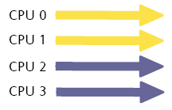
Figure 4 Concurrent - Multiple tasks happen at a time

- Incremental. The copying and mark-compact algorithms can’t eliminate JVM pauses, which in turn are proportional to the number of live objects.
As its name suggests, this mode does a bit of major collecting every time a minor collection is run. Global performance suffers from this execution mode but you get rid of those nasty pauses caused by major collections. This addresses the need for pause-less GC.
Incremental collection breaks up old object collection pauses into many tiny pauses even with large object areas. Instead of just a new and an old generation, this algorithm has a middle generation comprising many small spaces. There is some overhead associated with incremental collection; you might see as much as a 10-percent speed degradation.
Rules of thumb related to choosing the right execution mode are described in the next sub-section 2.2.6. Resolving GC Bottlenecks.

Diagnosing GC Bottlenecks
Some of the tools that one can use for detecting the same are the following command line options:

Tool/Command | Description
–verbose:gc | Prints information at every collection and therefore helps watch the GC cycles – both major and minor.  Sample output:  [GC 325816K->83372K(776768K), 0.2454258 secs]  [Full GC 267628K->83769K(776768K), 1.8479984 secs]  In this case we are looking at one minor and one full collection. The arrow differentiates the combined size of live objects before and after the GC pass. The third no. in the parentheses is the total available size of the Java heap, which is the total heap size minus one of the young generation's survivor spaces (because we need that for the copying collector in the young generation to work). The last number is the time taken by the GC pass.  Sample input:  java –verbose:gc -XX:+PrintGCDetails  -Xloggc:c:\gc.log <application>
-XX:+PrintGCDetails | Prints additional details.  Sample output:  [GC [DefNew: 64575K->959K(64576K), 0.0457646 secs] 196016K->133633K(261184K), 0.0459067 secs]]  DefNew: 64575K->959K(64576K) indicates that the minor collection recovered about 98% of the young generation, and took about 46 ms (0.0457646 secs)  196016K->133633K(261184K) indicates the usage of the entire heap was reduced to about 51%
-XX:+PrintGCTimeStamps  (turn on timestamps in GC logging)  -XX:+PrintHeapAtGC  -Xloggc:<filename>  (Log gc activity to a file)  -XX:+PrintTenuringDistribution | Other verbose options.
-XX:+HeapDump | This option when available can be used to observe memory allocation in a running Java™ application by taking snapshots of the heap over time. Using the _JAVA_HEAPDUMP=1 environment variable allows memory snapshots to be taken without modifying the java command line.  To enable this functionality, use the command-line option -XX:+HeapDump or set the environment variable _JAVA_HEAPDUMP=1 before starting the Java™ application. (e.g. export _JAVA_HEAPDUMP=1).  This output is similar to -Xrunhprof:heap=dump. The difference is that the thread info (THREAD START) and trace info (TRACE) will not printed to the output file.  With the option enabled, each time you send the process a SIGQUIT signal the JVM produces a dump of the Java™ heap (a Java™ heap snapshot), in hprof format. The name of the file will have the following format:  java_<pid>_<date>_<time>_heapDump.hprof.txt  By creating a series of these snapshots you can see how the number and size of objects varies over time.  Note: a full GC is executed prior to the Heap snapshot.
-XX:+HeapDumpOnOut OfMemoryError | This command line option causes the JVM to dump a snapshot of the Java heap when an Out Of Memory error condition has been reached. The heap dump format generated by HeapDumpOnOutOfMemoryError is in hprof binary format, and is written to filename java_pid<pid>.hprof in the current working directory.  The option -XX:HeapDumpPath=<file> can be used to specify the dump filename or the directory where the dump file is created. Running with application with -XX:+HeapDumpOnOutOfMemoryError does not impact performance. Please note the following known issue: The HeapDumpOnOutOfMemoryError option does not work with the low-pause collector (-XX:+UseConcMarkSweepGC). This option is available starting with the SDK 1.4.2.11 and JDK 5.0.04 releases.
JMap
JStat  And visualgc | Jstat is part of standard Java 5 distribution and can print out statistics in real time on a running JVM.  Sample output:  >jstat –gc  S0C S1C S0U S1U EC EU OC OU PC PU YGC YGCT FGC FGCT GCT  136512.0 136512.0 0.0 28820.6 546176.0 508081.8 1277952.0 121102.8 98304.0 45056.9 235  60.181 0 0.000 60.181  Where S0 and S1 are the two survivor spaces, E is Eden, O is the old space, P is permanent generation, YGC is ScavangeGC, FGC is Full GC, the suffic C means capacity, U means Used and T means time.  The same information you can get from jstat is available graphically using the visualgc tool. Unfortunately, the visualgc tool does not support logging of garbage collection activity to file.
HPROF: Heap profiler | Simple profiler agent shipped with JDK 5.0. Using the JVM Tools Interface (JVM TI), it writes out profiling information either to a file or to a socket in ASCII or binary format. This information can in turn be processed by a profiler front-end tool.  It is capable of presenting:  - CPU usuage,  - heap allocation statistics,  - complete heap dumps (for example: -Xrunhprof:heap=dump)  - states of all monitors and threads in the JVM  To find the complete list of options that can be passed to HRPOF, execute  >java -agentlib:hprof=help  (See [HPROF_DOC] or [JAVA5_TROUB] for more details)
HAT: Heap Analysis tool | The HAT helps debug unintentional object retention, i.e. objects that are no longer needed but kept alive due to references through some path from a live object.  HAT provides a simple means to browse the object topology in a heap snapshot generated using HPROF.  See [HAT_DOC] or [JAVA5_TROUB] for more details

Looking at GC output, one should look for the following:
- How often is garbage collection taking place? Compare the time stamps around the garbage collection.
- How long is garbage collection taking? Full garbage collection should not take longer than 3 to 5 seconds.
- What is your average memory footprint? In other words, what does the heap settle back down to after each full garbage collection? If the heap always settles to 85 percent free, you might set the heap size smaller.
- If the before and after combined size of live objects after full GCs are not much different, and full GCs happen very frequently – i.e. there are frequent GC passes that do not reclaim much memory, it indicates the application may be it could be either because the JVM really needs more memory due to the application’s need, or if there is a sudden spike,
- If there are many more full GC entries than the GC entries, the young generation is getting saturated with objects and can't find enough room to satisfy requests. Part of this may be due to the fact that objects in the young generation, if referenced from objects in the old generation, cannot be reclaimed, which is another argument against using object pools unnecessarily. Whatever the reason, if the heap isn't large enough to honor an allocation request, the JVM will resize the heap by extending its operating system's process footprint by some amount, up to the maximum specified by the –Xmx option to the JVM.

Resolving GC Bottlenecks
A number of command line options can be used to select a garbage collector, specify heap or generation sizes, modify garbage collection behavior, and obtain garbage collection statistics.
For a complete list of VM options refer to [SUN_VMOPTS].
Some rules of thumb for server apps are:

Task | Option | Comments
Setting minimum heap size | -Xms  (initial size of young generation + old generation) | If the value of –Xms parameter is smaller than –Xmx parameter, not all of the space reserved is immediately committed to the JVM. The uncommitted space is referred to as the “virtual” space. The different parts of the heap (permanent generation, tenured generation and young generation) can grow to the limit of the virtual space as needed.  Setting -Xms and -Xmx to the same value increases predictability by removing the most important sizing decision from the virtual machine. However, the virtual machine is then unable to compensate if you make a poor choice.
Setting the new generation size | -XX:NewSize  -XX:MaxNewSize  -XX:NewRatio ratio between tenured and young (eden + survivor spaces) generation)  -Xmn  (Example:  -Xmn256m) | This is the 2nd most influential factor affecting GC performance. The bigger the young generation is the less often minor collections will occur.  However, for a bounded heap size a larger young generation implies a smaller tenured generation, which will increase the frequency of major collections.  Unless you find problems with excessive old generation collections or pause times, grant plenty of memory to the young generation.  However, when you’re using the serial collector, do not grant the young generation more than half the total heap size. One reason for this is that the HotSpot JVM guarantees that if everything is alive in eden, it can all be copied to the old space, so that every collection triggers a full GC.
Setting maximum heap sizes | -Xmx (max size of young generation + old generation) | For server applications, keep the maximum heap size as high as you could afford, unless you have problems with pauses.  But make sure that the heap size is not larger than the free RAM on the system, in order to avoid paging.
Setting permanent generation | -XX:PermSize  (Initial Perm size)  -XX:MaxPermSize  (Max perm size) | The permanent generation does not have a noticeable impact on garbage collector performance for most applications. However, some applications dynamically generate and load many classes; for example, some implementations of JavaServer Pages (JSP) pages. These applications may need a larger permanent generation to hold the additional classes.  It is rare that rare that more than 128Mb of memory is required for the Permanent Generation.
For additional examples of the Hotspot VM options, see:
  - Java 1.4 VMs
    - Windows http://java.sun.com/j2se/1.4.2/docs/tooldocs/solaris/java.html
    - Solaris http://java.sun.com/j2se/1.4.1/docs/tooldocs/solaris/java.html#standard
    - Linux: http://java.sun.com/j2se/1.5.0/docs/tooldocs/linux/java.html#standard
  - Java 1.5: http://java.sun.com/j2se/1.5.0/docs/guide/vm/index.html
  - Java 1.6 :
Some rules of thumb regarding selection of appropriate GC are:

Type | Option | When to Use?
Serial | -XX:+UseSerialGC | If the application has a small data set (up to approximately 100MB.  If the application will be run on a single processor and there are no pause time requirements.
Parallel | -XX:+UseParNewGC  (multi-threaded collector for Eden space)  -XX:+UseParallelGC  -XX:+UseParallelOldGC  (parallel compaction) | If (a) peak application performance is the first priority and (b) there are no pause time requirements or pauses of one second or longer are acceptable.  However the sum of ParallelGCThreads in the JVMs being run on the machine should not exceed the number of CPUs/CPU cores on the machine. This can result in thread contention inside the JVM. Default number is the number of CPU cores.
Concurrent | -XX:+UseConcMarkSweepGC  -XX:+CMSIncrementalMode  (Incremental) | If response time is more important than overall throughput and garbage collection pauses must be kept shorter than approximately one second, then  - Select the concurrent collector with -XX:+UseConcMarkSweepGC. If only one or two processors are available, consider using incremental mode, described below.  - The incremental mode is meant to lessen the impact of long concurrent phases by periodically stopping the concurrent phase to yield back the processor to the application.

If the recommended collector above does not achieve the desired performance, first attempt to adjust the heap and generation sizes to meet the desired goals. If still unsuccessful, then try a different collector: use the concurrent collector to reduce pause times and use the parallel collector to increase overall throughput on multiprocessor hardware.

OutOfMemoryError

What is OutOfMemoryError
A common manifestation of a memory bottleneck is java.lang.OutOfMemoryError.
This error is thrown when there is insufficient space to allocate on the heap (or a particular area of the heap such as Permanent Generation or Old generation, etc.). That is, the GGC cannot make any further space available to accommodate a new object, and the heap cannot be further expanded.
Note that an OutOfMemoryError does not necessarily imply a memory leak, although it is a common cause of the error.
There are two primary sources of out of memory errors:
- Object recycling - Object cycling can be detected in the heap either through a visual tool that samples memory very frequently (once a second or less) — you will observe very narrow choppy marks in the heap — or through garbage collection logs. The key indicator to look for in reading garbage collection logs is frequent minor collections that reclaim small amounts of memory. Consider that the performance impact of garbage collection on your application is the result of two factors:
  - The frequency of garbage collection
  - The duration of each garbage collection
Object cycling impacts the frequency of garbage collection and can be therefore be detected by calculating the frequency of garbage collection.
- Lingering references -
See section 2.2.2 to understand the detailed message that may come along with this error.

Decoding the Detail Message
An early step to diagnose an OutOfMemoryError is to determine what the error means [TOOL_DESC].
Some of the possible error messages are as follows (taken/adapted from [TOOL_DESC] and [JAVA5_TROUB]:
- Exception in thread "main": java.lang.OutOfMemoryError: Java heap space
This indicates that an object could not be allocated in the Java heap.
The problem can be as simple as a configuration issue, where the specified heap size (or the default size, if not specified) is insufficient for the application.
In other cases, and in particular for a long-lived application, the message might be an indication that the application is unintentionally holding references to objects, and this prevents the objects from being garbage collected. The HAT tool can be used to view all reachable objects and understand which references are keeping each one alive.
One other potential source of OutOfMemoryError arises with applications that make excessive use of finalizers. If a class has a finalize method, then objects of that type do not have their space reclaimed at garbage collection time. Instead, after garbage collection the objects are queued for finalization, which occurs at a later time. In the Sun implementation, finalizers are executed by a daemon thread that services the finalization queue. If the finalizer thread cannot keep up with the finalization queue, then the Java heap could fill up and OutOfMemoryError would be thrown. One scenario that can cause this situation is when an application creates high-priority threads that cause the finalization queue to increase at a rate that is faster than the rate at which the finalizer thread is servicing that queue. The jConsole management tool can be used to monitor the number of objects that are pending finalization.
- Exception in thread "main": java.lang.OutOfMemoryError: PermGen space
The detail message PermGen space indicates that the permanent generation is full. The permanent generation is the area of the heap where class and method objects are stored. If an application loads a very large number of classes, then the size of the permanent generation might need to be increased using the -XX:MaxPermSize option.
Interned java.lang.String objects are also stored in the permanent generation. The java.lang.String class maintains a pool of strings. When the intern method is invoked, the method checks the pool to see if an equal string is already in the pool. If there is, then the intern method returns it; otherwise it adds the string to the pool. In more precise terms, the java.lang.String.intern method is used to obtain the canonical representation of the string; the result is a reference to the same class instance that would be returned if that string appeared as a literal. If an application interns a huge number of strings, the permanent generation might need to be increased from its default setting.
- Exception in thread "main": java.lang.OutOfMemoryError: Requested array size exceeds VM limit
The detail message Requested array size exceeds VM limit indicates that the application (or APIs used by that application) attempted to allocate an array that is larger than the heap size. For example, if an application attempts to allocate an array of 512MB but the maximum heap size is 256MB then OutOfMemoryError will be thrown with the reason Requested array size exceeds VM limit. In most cases the problem is either a configuration issue (heap size too small), or a bug that results in an application attempting to create a huge array, for example, when the number of elements in the array are computed using an algorithm that computes an incorrect size.
- Exception in thread "main": java.lang.OutOfMemoryError: request <size> bytes for <reason>. Out of swap space?
This happens when an allocation from the native heap failed and the native heap might be close to exhaustion. The message indicates the size (in bytes) of the request that failed and the reason for the memory request. In most cases the <reason> part of the message is the name of a source module reporting the allocation failure, although in some cases it indicates a reason.
- Exception in thread "main": java.lang.OutOfMemoryError: <reason> <stack trace> (Native method)
This is an indication that a native method has encountered an allocation failure. The difference between this and the previous message is that the allocation failure was detected in a JNI or native method rather than in Java VM code.

Diagnosing Leaks in Java Language Code
Diagnosing leaks in Java code can be often iterative and time-consuming. Some of the tools one can use are:
- HAT (Heap Analysis Tool) – The following details on this list item is taken from [JAVA5_TROUB].
HAT is useful when debugging unecessary object retention (or memory leaks). It provides a way to browse an object dump, view all reachable objects in the heap, and understand which references are keeping an object alive.
One way to obtain a heap dump is to run the application with the HPROF profiler agent:
java -agentlib:hprof=file=dump.hprof,format=b <Application>
If the VM is embedded or is not started using a command line launcher that allows additional options be provided then it may be possible to use the JAVA_TOOLS_OPTIONS environment variable so that the -agentlib option is automatically added to the command line.
Once the application is running with HPROF, a heap dump can be created by pressing Ctrl-\ or Ctrl-Break – depending on the platform on the application console/standard output. An alternative approach on Solaris and Linux is to send a QUIT signal via the kill -QUIT <pid> command. When the signal is received a heap dump is created; in this case the dump.hprof file is created. A dump file can contain multiple heap dumps. If Ctrl-\ or Ctrl-Break is pressed a number of times then the second, and subsequent, dumps are appended to the file.
Recent update releases have added two new ways to obtain a heap dump in binary format:
  - Java 5.0 update 7: -XX:+HeapDumpOnOutOfMemoryError command-line option tells the HotSpot VM to generate a heap dump when an OutOfMemoryError occurs.
  - Java 5.0 update 14: -XX:+HeapDumpOnCtrlBreak command-line option tells the HotSpot VM to generate a heap dump when a Ctrl-Break or SIGQUIT signal is received.
Once a heap dump is created it can be used as input to HAT. HAT processes the dump file and then starts a HTTP server on a specified port. Once started you can use any browser to connect to HAT and browse the heap.

>java -jar $HAT_BIN/hat.jar -port 7000 dump.hprof
Open http://127.0.0.1:7000/ on the browser.
For more details on understanding the HAT output, refer to [JAVA5_TROUB].

- Third-party memory debuggers. JProbe from Quest Software and OptimizeIt from Borland are two examples of commercial tools with memory debugging capabilities.

Resolving OutOfMemoryErrors

Probable Cause | Counter-measures
The JVM is really out of enough memory. | Add more heap. Increase max memory. –Xmx
If there are too many threads and the stack size is large (either default or specifically set using –Xss), then a significant amount of stack space may be wasted.  This is especially true with applications that an application moves to a large number of threads.  The default stack sizes are:  - Sparc – 512k (32-bit vm) and 1024k (64-bit vm)  - Win – read from the binary (java.exe - 320k to 1024k) | If that is the case, reducing the same using –Xss=<lower value> may be an option.  Least amount of stack space allowed per thread is 64k.
Application…

Memory leaks

Reasons for Memory Leaks
A Java memory leak is the result of maintaining a lingering reference to an unused object: you are finished using an object, but because one or more other objects still reference that object, the garbage collector cannot reclaim its memory.
The memory occupied by that object is thus lost from the usable heap. Memory leaks in Java are a dangerous contributor to garbage collection bottlenecks.
Typically high loads accelerate the magnification of a leakage and results in an OutOfMemoryError. For example, these types of memory leaks typically occur during Web requests, and while one or two leaked objects may not crash your application server, 10,000 or 20,000 requests might. Furthermore, most objects that are leaked are not simple objects such as Integer s or Double s, but rather represent subgraphs within the heap. For example, you may inadvertently hold on to a Person object and that Person object has a Profile object that has several PerformanceReview objects that each maintain sets of data. Rather than losing 100 bytes of memory that the Person object occupies, you lose the entire sub-graph that might account for 500KB or more of memory.
Memory leaks are more damaging than memory overuse, because a memory leak ultimately leads to system instability. Over time, garbage collection occurs more frequently until finally the heap is exhausted and Java fails with a fatal OutofMemory exception. Note that there can be reasons other than memory leak for an OutOfMemoryError.

Determining if an application has memory leak
There is a memory leak if one of the following occurs:
- The amount of memory used immediately after each garbage collection increases significantly. The saw-tooth pattern will look more like a staircase.
- The saw-tooth pattern has an irregular shape.
Also, look at the difference between the number of objects allocated and the number of objects freed. If the gap between the two increases over time, there is a memory leak.
If heap consumption indicates a possible leak during a heavy workload (the application server is consistently near 100% CPU utilization), yet the heap appears to recover during a subsequent lighter or near-idle workload, this is an indication of heap fragmentation. Heap fragmentation can occur when the JVM is able to free sufficient objects to satisfy memory allocation requests during garbage collection cycles, but the JVM does not have the time to compact small free memory areas in the heap into larger contiguous spaces.
Another form of heap fragmentation occurs when small objects (less than 512 bytes) are freed. The objects are freed, but the storage is not recovered, resulting in memory fragmentation.
Heap fragmentation can be avoided by turning on the -Xcompactgc flag in the JVM advanced settings command-line arguments. The -Xcompactgc ensures that each garbage collection cycle eliminates fragmentation, but this setting has a small performance penalty.

One can use a profiler to detect a memory leak. Upon successive GC, the graph of the used memory should have a sawtooth shape. Each drop on the graph corresponds to a garbage collection.

Weblogic Application Server (WLS)

Understanding WLS JDBC Connection Pool Options
The following table summarizes some of the settings that have major impact on performance:

Setting | Description
Small Connection pool | Pros: Faster access on the connection table  Cons: May not have enough connections to satisfy requests. Requests may spend more time in the queue.
Large connection pool | Pros: More connections to fulfill requests. Requests will spend less (or no) time in the queue.  Cons: Slower access on the connection table.
Initial Capacity | Set the value of initial capacity equal to the value for maximum capacity to improve performance. This is to avoid connection creation delays.
Test Connection on Reserve | When Test Connections on Reserve is enabled, the server instance checks a database connection prior to returning the connection to a client. This helps reduce the risk of passing invalid connections to clients.  However, it is a fairly expensive operation.
Cache Prepared and Callable statements | Reusing prepared and callable statements reduces CPU usage on the database server, improving performance for the current statement and leaving CPU cycles for other tasks.  You can use Statement Type Cache (LRU, fixed) and Statement Cache Size (total number of statements to cache) settings.  Statement caches can be defined at connection level as well as at data source level.  However, keep in mind the following limitations that statement caches have:  - Calling a Stored Statement After a Database Change May Cause Errors  - Statements in the Cache May Reserve Database Cursors  (For more issues and how to resolve them, see “Configuring JDBC Data Sources”)
Connection reserve timeout | When an application requests a connection from a data source, if all connections in the data source are in use and if the data source has expanded to its maximum capacity, the application will get a Connection Unavailable SQL Exception.  To avoid this, you can configure the Connection Reserve Timeout value (in seconds) so that connection requests will wait for a connection to become available. After the Connection Reserve Timeout has expired, if no connection becomes available, the request will fail and the application will get a PoolLimitSQLException exception.  The default value is 10 seconds.
Maximum waiting for connection | Connection requests that wait for a connection block a thread. If too many connection requests concurrently wait for a connection and block threads, your system performance can degrade. To avoid this, you can set the Maximum Waiting for Connection (HighestNumWaiters) attribute, which limits the number connection requests that can concurrently wait for a connection.  If the maximum number of requests has been met, a SQLException is thrown when an application requests a connection.
Inactive connection timeout | A leaked connection is a connection that was not properly returned to the connection pool in the data source. To automatically recover leaked connections, you can specify a value for this, for example 30 seconds.  When set to 0 (the default value), this feature is turned off.

Understanding Other Key WLS Tuning Factors
Some of the key WLS options are:
- ThreadCount attribute of ExecuteQueue (in config.xml): This equals the number of simultaneous operations that can be performed by applications that use the execute queue.
As work enters an instance of WebLogic Server, it is placed in an execute queue. This work is then assigned to a thread that does the work on it.
Threads consume resources, such as stack space (stack space = stacksize * no. of threads), so use this with care. Too many will degrade performance by causing more memory to be used and increasing context switching.
Default are:
- 15 threads for Server Mode = Development
- 25 threads for Server Mode = Production
Some general rules of thumb are:
- If the client app is thin and does a lot of work through remote invocation, that client app will spend more time connected – and thus will require a higher thread count than one that does a lot of client-side processing.
- Similarly, if your app makes lot of DB calls that take a long time to return, you will need more execute threads than an application that makes calls that are short and turn over very rapidly.
To determine optimum thread count for an execute queue, monitor the queue’s throughput while the app is running at maximum queue. Increase the number of threads in the queue and repeat the load test until you reach the optimal throughput for the queue. (At some point, increasing the number of threads will lead to enough context switching that the throughput for the queue begins to decrease.)
For more details refer to [WLS_10_07].

Option | Description
ExecuteQueue | Requests to a server instance are placed in an execute queue. Each request is assigned to a thread within the queue that performs the work.  By default, a new server instance is configured with a default execute queue, weblogic.kernel.default, that contains 15 threads. In addition, WebLogic Server provides two other pre-configured queues  weblogic.admin.HTTP—Available only on Administration Servers, this queue is reserved for communicating with the Administration Console; you cannot reconfigure it.  weblogic.admin.RMI—Both Administration Servers and Managed Servers have this queue; it is reserved for administrative traffic; you cannot reconfigure it.  Attributes:  Queue Length - The maximum number of simultaneous requests that the server instance can hold in the queue.
ThreadCount attribute of ExecuteQueue
(config.xml)

Tools to Monitor WLS Performance
Watching the console in Weblogic can provide good first inputs on what may be going wrong:

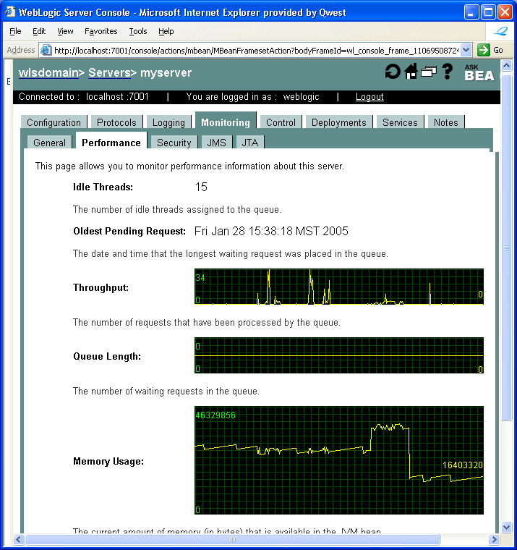
For example, the above screenshot shows:
- Queue depth
- Throughput
- Memory usage
JRockit console has other great information such as:
- Heap
- CPU/JVM info
- Detailed GC info

Resolving Bottlenecks

Probable Cause | Counter-measures

System (OS), Network and Database Tuning

System memory

Understanding System Memory Bottlenecks
Maintaining watch directly on the system memory (RAM) is not usually that helpful in identifying performance problems. A better indication that memory might be affecting performance can be gained by watching for paging of data from memory to the swap files.
Most current operating systems have a virtual memory that is made up of the actual (real) system memory using RAM chips, and one or more swap files on the system disks. Processes that are currently running are operating in real memory. The operating system can take pages from any of the processes currently in real memory, and swap them out to disk. This is known as paging. Paging leaves free space in real memory to allocate to other processes that need to bring in a page from disk.
The term swapping refers to moving entire processes between main memory and the swap file. Most modern operating systems no longer swap processes; instead, they swap pages from processes, thus the term "paging."
Obviously, if all the processes currently running can fit into the real memory, there is no need for the system to page out any pages. However, if there are too many processes to fit into real memory, paging allows the system to free up system memory to run further processes.
Paging affects system performance in many ways:
- If a process has had some pages moved to disk and the process becomes runnable, the operating system has to pull back the pages from the disk before that process can be run. This leads to delays in performance.
- In addition, both the CPU and the disk I/O subsystem spend time doing the paging, reducing available processing power and increasing the load on the disks. This cascading effect involving both the CPU and I/O can degrade the performance of the whole system in such a way that it may be difficult to even recognize that the paging is the problem.
- The extreme version of too much paging is thrashing, in which the system is spending so much time moving pages around that it fails to perform any other significant work. Beyond this, one would likely to have a system crash.
A little paging is not bad. But at the point where paging becomes a significant overhead, the system is overloaded.

Tools to Monitor System Memory
To monitor paging, one can use the following tools:
- In Unix, commands such as vmstat and iostat provide details as to the level of paging, disk activity, and memory levels.
- On Windows, the performance monitor has categories to show these details, as well as being able to monitor the system swap files.
Command | OS | Description
ps | Solaris | Number of light-weight threads (for example in Solaris) * thread stack size (-Xss in JVM) is the total memory reserved by the threads spawned in the application, whether or not the threads will use that memory.  For example, if the -Xss=3M and number of threads = 200 means 200*3 = 600MB of memory will be used for the threads stack - whether or not they are going to use it  This could be one reason for OutOfMemoryError.  ps -eLf | grep <parameter> | wc –l  $ps -eLf | grep qcoaop | wc -l //app name substituted as parameter  $ps -eLf | grep 20774 | wc -l // process ID of the managed server substituted as parameter
Vmstat  (virtual memory statistics) |  | The vmstat utility on UNIX can be used to monitor memory utilization.  Example: $vmstat 5  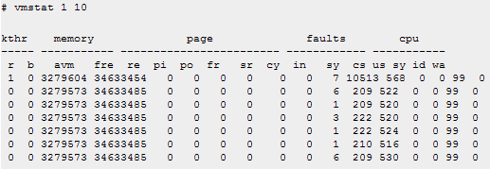  The most important criteria after having sufficient physical memory in the machine is to have sufficient swap space to sustain the virtual memory requirements of the portal/access manager web containers, directory process's and other associated process's.  Columns 'pi' and 'po' indicate the number of paging space page-ins/per second and the number of paging space page-outs/per second. If the values are constantly non-zero, there is most likely a memory bottleneck. Occasional non-zero values don't necessarily indicate a problem since paging is the main principal of virtual memory.  For summary stats use $vmstat –s  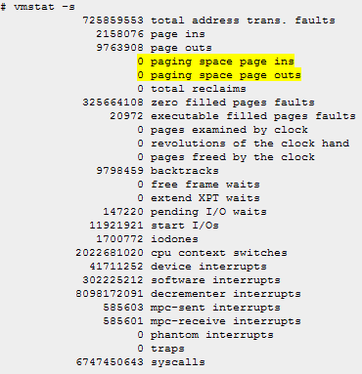
ps | Linux | The following lists processes by mem usage.  %ps -e -orss=,args= | sort -b -k1,1n | pr -TW$COLUMNS  The following lists processes by memory usage (Kbs):  $ps -eo pid,vsz,args | sort +1n
ps | Solaris 8
free –m | Linux | It shows how much memory and swap space is in use.  Sample:  lxdnd670:/home/00/netwrxoaop>free -m  total used free shared buffers cached  Mem: 7803 7788 15 0 284 5525  -/+ buffers/cache: 1977 5825  Swap: 8191 0 8191

Resolving System Memory Bottlenecks
The rules of thumb for server applications are:
- A JVM heap which either always or at times - during runtime, turn out to be larger than available RAM, will cause the OS to swap heap memory to disk. This can cause significant performance degradation.
The maximum heap size should always be smaller than the amount of memory installed on the machine, to avoid excessive page faults and thrashing.
Also note that the VM always uses more memory than the heap size. The memory required for internal VM functionality, native libraries outside of the VM, and permanent generation memory (for the Sun VM only: memory required to store classes and methods) is allocated in addition to the heap size settings.
- If there is more paging than is optimal, the system's RAM is insufficient or processes are too big.
To improve this situation, you need to reduce the memory being used by reducing the number of processes or the memory utilization of some processes.
Alternatively, you can add RAM.
If your application is the one causing the paging (otherwise, either the system needs an upgrade, or someone else's processes may also have to be tuned), you could reduce the memory resources you are using.

- ss

CPU

Understanding CPU Bottlenecks
For servers whose primary role is that of an application or database server, the CPU is a critical resource and can often be a source of performance bottlenecks.
Two aspects of the CPU are worth watching as primary performance points:
- CPU utilization: This is usually expressed as %age terms. This is simply the percentage of the CPU (or CPUs) being used by all the various threads.
If this is up to 100% for significant periods of time, one may have a problem. On the other hand, if it isn't, the CPU is underutilized, but that is usually preferable.
Low CPU usage can indicate that your application may be blocked for significant periods on disk or network I/O. High CPU usage can indicate thrashing (lack of RAM ) or CPU contention (indicating that you need to tune the code and reduce the number of instructions being processed to reduce the impact on the CPU).
A reasonable target is 75% CPU utilization. This means that the system is being worked towards its optimum, but that you have left some slack for spikes due to other system or application requirements. However, note that if more than 50% of the CPU is used by system processes (i.e., administrative and operating-system processes), your CPU is probably underpowered. This can be identified by looking at the load of the system over some period when you are not running any applications.
It is important to note that high CPU utilization does not always mean that a CPU is busy doing work; it might be waiting on another subsystem.
- Runnable queue of processes and threads – also referred to as load or the task queue): This indicates the average number of processes or threads waiting to be scheduled for the CPU by the operating system. They are runnable processes, but the CPU has no time to run them and is keeping them waiting for some significant amount of time. One guideline from Adrian Cockcroft is that performance starts to degrade if the run queue grows bigger than four times the number of CPUs.
There is a common misconception that the CPU is the most important part of the server. This is not always the case, and servers are often overconfigured with CPU and underconfigured with disks, memory, and network subsystems. Only specific applications that are truly CPU intensive can take advantage of today's high-end processors.

Tools to Monitor CPU
The CPU and many other parts of the system can be monitored using system-level utilities.
On Windows, the task manager and performance monitor can be used for monitoring.
On Unix, a performance monitor (such as perfmeter) is usually available, as well as utilities such as vmstat.
If you can upgrade the CPU of the target environment, doubling the CPU speed is usually better than doubling the number of CPUs. And remember that parallelism in an application doesn't necessarily need multiple CPUs. If I/O is significant, the CPU will have plenty of time for many threads.

Command | OS | Description
top | Linux, Unix | The top command provides dynamic view of CPU usage by process.  Sample output from top:  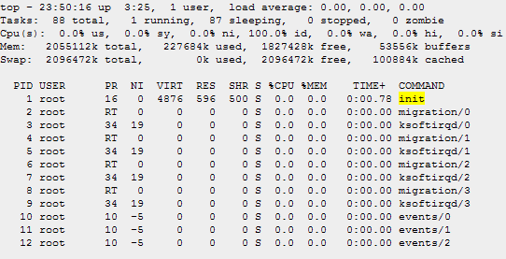
mpstat | Linux, Unix | This command reports per-processor statistics. For aggregates one can use vmstat as described below.  mpstat with an argument between 5 seconds to 10 seconds can provide good information well enough.  Use “mpstat –P All” to monitor individual processor performance.  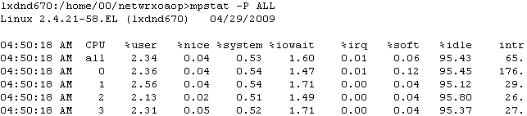
sar | Linux,  Unix | The following displays overall system CPU usage 10 seconds apart for 3 times. If you just want to know if your system is busy or not, then use 'sar'.  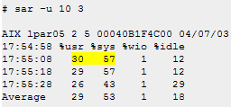  The output shows that the system spent 29% in user mode (your applications most likely), 53% in system mode (OS-related, e.g., CPU-comsuming libraries), and 1% waiting for IO requests, and was idle 18% of the time.  If %usr + %sys ~ 100%, there may be a CPU bottleneck.
iostat | Linux | The iostat command reports Central Processing Unit (CPU) statistics and input/output statistics for devices and partitions. It can be use to find out your system's average CPU utilization since the last reboot.
ps | Linux | #ps -e -o pcpu,cpu,nice,state,cputime,args --sort pcpu | sed '/^ 0.0 /d'  List few processes highest % cpu usage.
ps | Unix, Linux | $ps -eo pid,pcpu,args | sort +1n  List processes by % cpu usage
Prstat | Unix | Gives a running commentary of active process statistics (CPU and memory usage). The output from “prstat –cvm” is very useful.
vmstat | Unix | For multi-processor systems vmstat averages the number of CPUs into the output. Mpstat command can be used for pre-processor stats.  Vmstat displays the amount of virtual memory in use, how much memory is swapped in and out each second, the number of processes currently running and sleeping, the number of interrupts and context switches per second and the usage percentages of the CPU.  The following command displays a summary of what the system is doing every five seconds for 3 times.  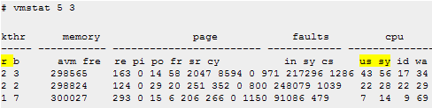  Always ignore the first line of vmstat output.  If run queue (r column) divided by number of CPUs is greater than 1, there may be a CPU bottleneck.  If the us + sy (%age of usage of CPU time spent in user and system time) is close to 100% there may be CPU bottleneck. The "id" column is CPU idle time.  2) Sample output from vmstat on a heavily used server:  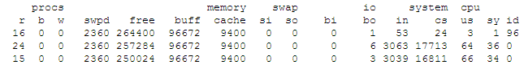  The interesting numbers here are the first one – r – runnable queue: This is the number of the process that are on the run queue:  This value shows how many process are ready to be executed, but can not be ran at the moment because other process need to finish. For lightly loaded systems, this is almost never above 1-3, and numbers consistently higher than 10 indicate the machine is getting pounded.  Other interesting values include the "system" numbers for in and cs. The in value is the number of interrupts per second a system is getting. A system doing a lot of network or disk I/o will have high values here, as interrupts are generated every time something is read or written to the disk or network.
uptime |  | To find out the system load average, this is the most common used command.  Sample output:  3:04pm up 4 day(s), 10:37, 16 users, load average: 0.11, 0.10, 0.12  Here it tells us that current time is 3:04 pm, system is up four days since 10:37, there are 16 users, five minutes ago load average was 0.11, ten minutes ago was 0.10 and fifteen minutes ago was 0.12.
Windows Task Manager | Win | Windows task manager can be used to monitor CPU usage on Windows.  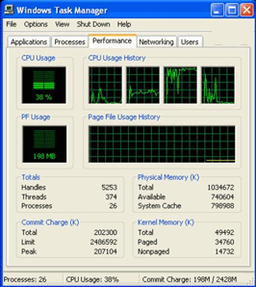  The above figure shows a 4-CPU system with average CPU usage 38%. Individual CPU usage is also shown clearly.
Perfmon | Win | To automate and capture CPU usage into a file using 'perfmon' tool that comes with Windows 2003.

Resolving CPU Bottlenecks
If you determine that the application is CPU bound, you can take one of the following approaches:
- Profile the application code to determine if the part of the application can be optimized. For example, using more efficient algorithms to avoid CPU usage. But beware of the fact that you could end up expending a great deal of effort without gaining much.
- Add extra CPUs

Disk & Disk I/O
The OS disk subsystem is a common reason for performance degradation.
Applications are considered to be I/O-bound when CPU cycles are wasted simply waiting for I/O tasks to finish.

Understanding File Descriptor Bottlenecks
One common reason why applications perfro.. file descriptors….

Understanding Other Disk Bottlenecks

A server exhibiting the following symptoms might be suffering from a disk bottleneck (or a hidden memory problem):
- Slow disks will result in:
  - Memory buffers filling with write data (or waiting for read data), which will delay all requests because free memory buffers are unavailable for write requests (or the response is waiting for read data in the disk queue).
  - Insufficient memory, as in the case of not enough memory buffers for network requests, will cause synchronous disk I/O.
- Disk utilization, controller utilization, or both will typically be very high.
- Most LAN transfers will happen only after disk I/O has completed, causing very long response times and low network utilization.
- Disk I/O can take a relatively long time and disk queues will become full, so the CPUs will be idle or have low utilization because they wait long periods of time before processing the next request.
There are two ways to to approach disk bottleneck analysis: real-time monitoring and tracing.
- Real-time monitoring must be done while the problem is occurring. This might not be practical in cases where system workload is dynamic and the problem is not repeatable. However, if the problem is repeatable, this method is flexible because of the ability to add objects and counters as the problem becomes clear.
- Tracing is the collecting of performance data over time to diagnose a problem. This is a good way to perform remote performance analysis. Some of the drawbacks include the potential for having to analyze large files when performance problems are not repeatable, and the potential for not having all key objects and parameters in the trace and having to wait for the next time the problem occurs for the additional data.

Tools to Monitor Disk Bottlenecks

Command | OS | Description
Plimit | Solaris | Maximum number of file descriptors provided to the process:  $plimit <pid>  Sample output:  z2omt30k:/proc/20774/fd> plimit 20774  20774: /opt/bea/wlsserver8.1.6/jdk142_11/bin/java -server -verbosegc -Xms2560  resource current maximum  time(seconds) unlimited unlimited  file(blocks) unlimited unlimited  data(kbytes) unlimited unlimited  stack(kbytes) 8192 unlimited  coredump(blocks) unlimited unlimited  nofiles(descriptors) 1024 1024  vmemory(kbytes) unlimited unlimited
ls |  | Number of used file descriptors by a process:  > ls -la /proc/20774/fd/ | wc -l  83  (or) >ls -CFl /proc/20774/fd
Ulimit | Solaris | Display and change the limit on number of open files)  Solaris ulimit command specifies the number of open files permitted.  Check the UNIX reference pages on ulimit for the syntax for different shells. For KornShell (ksh) the command is: ulimit -n 1024  Use the command “ulimit –a” to display the current values for all limitations on system resources. Sample output:  time(seconds) unlimited  file(blocks) unlimited  data(kbytes) unlimited  stack(kbytes) 8192  coredump(blocks) unlimited  nofiles(descriptors) 10000  vmemory(kbytes) unlimited
vmstat | Linux | One way to track disk usage on a Linux system is by using the vmstat tool. The important columns in vmstat with respect to I/O are the bi and bo fields. These fields monitor the movement of blocks in and out of the disk subsystem. Having a baseline is key to being able to identify any changes over time.  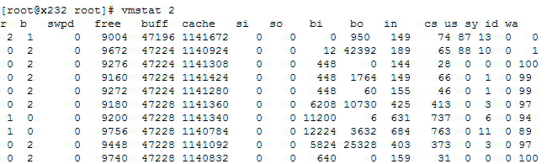
iostat |  | Performance problems can be encountered when too many files are opened, read and written to, then closed repeatedly. This could become apparent as seek times (the time it takes to move to the exact track where the data is stored) start to increase. Using the iostat tool, you can monitor the I/O device loading in real time. Different options enable you to drill down even deeper to gather the necessary data.  Iostat command can be used to view disk activities on Unix/Linux machines. The x argument allows extended statistics to be reported and the c option reports the CPU utilization for the interval.  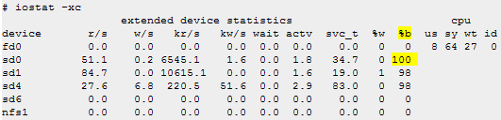  It looks from above that sd0 is very busy (100%!). Next step may be to find out what is using it.  Similarly the following figure shows a potential I/O bottleneck on the device /dev/sdb1. This output shows average wait times (await) of about 2.7 seconds and service times (svctm) of 270 ms.  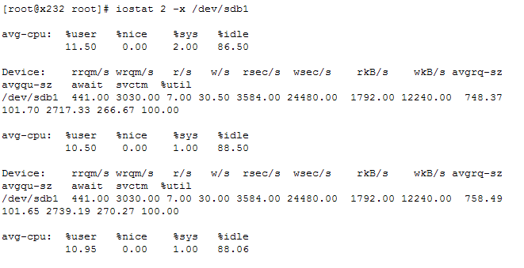
df  (Disk free space) |  | df reports the number of total, used, and available disk blocks (one disk block equals 512 bytes) in file systems.  d0sgi6[83]% df  Filesystem Type blocks use avail %use Mounted on  /dev/root efs 37615 20519 17096 55% /  /dev/usr efs 853020 517401 335619 61% /usr  /dev/dsk/dks0d2s7 efs 1975100 1695823 279277 86% /exports/data0  /dev/dsk/dks0d1s2 efs 879625 740154 139471 84% /exports/usr/people  d0chb:/d0dist nfs 4426512 3956200 470312 89% /d0dist  d0cha:/d0library nfs 4319768 2972823 1346945 69% /d0library  d0sgi0:/usr/local nfs 651875 146295 505580 22% /usr/local  d0sgi0:/usr/products nfs 2406580 2268638 137942 94% /usr/products  d0sgi0:/exports/usr/peo nfs 7603592 7230643 372949 95% /tmp_mnt/d0sgi0/usr0
du  (Disk usage) |  | du reports the number of blocks contained in specified files or directories, if no names are given, the current directory is used.  Useful options:  -s causes only the grand total (for each of the specified names) to be given.  -k will cause du to express all block counts in terms of 1024 byte blocks, instead of the default 512 byte blocks.  Example:  d0sgi6[92]% ls -l  total 5  drwxr-xr-x 2 berezhno D0 512 Sep 1 1994 berezhnoi/  drwxr-xr-x 2 bhat D0 512 Nov 9 1993 bhat/  drwxr-xr-x 2 diesburg D0 512 Nov 9 1993 diesburg/  drwxr-xr-x 4 dongzhao D0 512 Nov 14 11:44 dongzhao/  drwxr-xr-x 6 root sys 512 Jan 20 1994 reco_comp/  d0sgi6[93]% du -sk *  5545 berezhnoi  1 bhat  1 diesburg  11557 dongzhao  830735 reco_comp
Multiple  (sar, more and lsof) | Linux | There are many tools to monitor disk io in Linux, such as 'iostat', 'sar', and 'sadc'. It is easy to use these tools to find out which device (or hard disk) is having the busiest I/O activities, but it is a bit difficult to find out which program (the exact pid) that is actually using a particular device.  # sar -d  Linux 2.4.21-27.ELsmp (pw101) 12/04/2005  12:00:00 AM DEV tps rd_sec/s wr_sec/s  ....  Average: dev8-128 7.16 5.37 75.07  Average: dev8-129 7.16 5.37 75.07  Average: dev8-130 0.00 0.00 0.00  ....  The above command finds the busiest device. To determine what that device is, do:  # more /proc/devices  Character devices:  1 mem  2 pty  3 ttyp  4 ttyS  5 cua  7 vcs  ...  Block devices:  1 ramdisk  2 fd  3 ide0  7 loop  8 sd  ...  71 sd  129 sd  The above example indicates the 'Block device' 8 is 'sd' or scsi disk, and #129 is one of scsi disks in the system. So 'sar -d' tells you that one of the scsi disks, or device 'dev8-129' is busy.  Now the following command is a bit busy, but you can always strip away piped commands to see what output is like for each command. But the shown example give you which program (along with its pid) has the most open files on a given busy device. In our example, the busy device we are interested is 'dev8-129', but is represented as '8,129' in the 'lsof' output.  #lsof | grep "8,129" | awk '{print $1" "$2}' | uniq -c | sort -n -r  [count p pid]  307 java 31916  307 java 31915  307 java 31914  307 java 31913  307 java 31912  307 java 31911  307 java 31910  307 java 31909  307 java 31908  307 java 31907  307 java 31906  307 java 31905  307 java 31904  307 java 31903  307 java 27645  The above output gives a clue as to which process(es) to look into for disk I/O problems (i.e., 'java'). The 'java' processes are having the largest number of open files, and chances are doing the most disk I/O. Of course, some files maybe memory-cached, so this method may not always work.
Filemon | Unix-AIX | The command can output busiest fs, lv, and pv, AND associate them with processes. The following example show a snapshot of system disk I/O for 10 seconds:  #filemon -O all -o fmon.out; sleep 10; trcstop  Enter the "trcstop" command to complete filemon processing  [filemon: Reporting started]  # [filemon: Reporting completed]  [filemon: 10.945 secs in measured interval]  # more fmon.out:  Sun Dec 4 18:40:14 2005  System: AIX pw101 Node: 5 Machine: 002FBF7D4C00  Cpu utilization: 1.0%  Cpu allocation: 100.0%  Most Active Files  ------------------------------------------------------------------------  #MBs #opns #rds #wrs file volume:inode  ------------------------------------------------------------------------  1.2 4 296 0 unix /dev/hd2:63102  0.7 2 170 0 services /dev/hd4:1173  0.5 242 124 0 group /dev/hd4:600  0.1 8 16 0 ksh.cat /dev/hd2:79522  0.0 6 12 0 default.env /dev/hd9var:8199  ....  Most Active Segments  ------------------------------------------------------------------------  #MBs #rpgs #wpgs segid segtype volume:inode  ------------------------------------------------------------------------  0.0 0 1 1460347 client  Most Active Logical Volumes  ------------------------------------------------------------------------  util #rblk #wblk KB/s volume description  ------------------------------------------------------------------------  0.00 0 24 1.1 /dev/hd8 jfs2log  0.00 0 8 0.4 /dev/hd9var /var  Most Active Physical Volumes  ------------------------------------------------------------------------  util #rblk #wblk KB/s volume description  ------------------------------------------------------------------------  0.00 0 32 1.5 /dev/hdisk0 N/A  ...  Detailed Physical Volume Stats (512 byte blocks)  ------------------------------------------------------------------------  VOLUME: /dev/hdisk0 description: N/A  writes: 4 (0 errs)  write sizes (blks): avg 8.0 min 8 max 8 sdev 0.0  write times (msec): avg 5.321 min 2.983 max 7.837 sdev 1.778  write sequences: 4  write seq. lengths: avg 8.0 min 8 max 8 sdev 0.0  seeks: 4 (100.0%)  seek dist (blks): init 59548744,  avg 4780893.3 min 8 max 7171344 sdev 3380596.4  seek dist (%tot blks):init 41.53385,  avg 3.33456 min 0.00001 max 5.00184 sdev 2.35789  time to next req(msec): avg 1471.627 min 6.890 max 4202.723 sdev 1716.529  throughput: 1.5 KB/sec  utilization: 0.00  Two things to notice here:  - 'jfs2log' is causing the most active lv '/dev/hd8'  - number of 'seeks' is the same as number of 'writes' or 'seeks' is 100%, a possible indication that file system is highly fragmented. You may need to run 'smit dejfs' to degragment the fs.

Performance Tuning Options
After verifying that the disk subsystem is a system bottleneck, several solutions are possible. These solutions include the following:
- If the workload is of a sequential nature and it is stressing the controller bandwidth, the solution is to add a faster disk controller. However, if the workload is more random in nature, then the bottleneck is likely to involve the disk drives, and adding more drives will improve performance.
- Add more disk drives in a RAID environment. This spreads the data across multiple physical disks and improves performance for both reads and writes. This will increase the number of I/Os per second. Also, use hardware RAID instead of the software implementation provided by Linux. If hardware RAID is being used, the RAID level is hidden from the OS.
- Consider using Linux logical volumes with striping instead of large single disks or logical volumes without striping.
- Offload processing to another system in the network (users, applications, or services).
- Add more RAM. Adding memory increases system memory disk cache, which in effect improves disk response times.

Network Performance

Understanding Network Bandwidth Bottlenecks
A common definition of bandwidth is: the rate of the data communications transmission, usually measured in bits-per-seconds.
The app server, DB server and all nodes requires enough bandwidth to connections. For example, a machine running WebLogic Server requires enough network bandwidth to handle all WebLogic Server client connections.
- In the case of programmatic clients, each client JVM has a single socket to the server, and each socket requires dedicated bandwidth. A WebLogic Server instance handling programmatic clients should have 125–150 percent of the bandwidth that a similar Web server would handle [WLS_10_07].
One can use network monitoring tools provided by the network OS vendor to see what the load is on the network system. One can also use common OS tools such as netstat (for Solaris) or System Monitor (perfmon) for Windows, to monitor network utilization. If the load is very high, bandwidth may be a bottleneck for your system.
Also, monitor the amount of data being transferred across your network by checking the data transferred between the application and the application server, and between the application server and the DB server. This amount should not exceed your network bandwidth. To verify this, monitor the network statistics for retransmission and duplicate packets, as follows:
$netstat –s –P tcp
// to view all available TCP params

Latency
The bandwidth refers to how much data can be sent down the communication channel for a given period of time (e.g., 64 kilobits per second) and is limited by the link in the communication chain that has the lowest bandwidth. The latency is the amount of time a particular data packet takes to get from one end of the communication channel to the other.
Bandwidth tells you the limits within which your application can operate before the performance becomes affected by the volume of data being transmitted. Latency often affects the user's view of the performance even when bandwidth isn't a problem.
For example, on a LAN, the latency might be 10 milliseconds. In this case, you can ignore latency considerations unless your application is making a large number of transmissions. If your application is making a large number of transmissions, you need to tune the application to reduce the number of transmissions being made. (That 10-ms overhead added to every transmission can add up if you just ignore it and treat the application as if it were not distributed.)
You can determine the basic round trip time for data packets from any two machines using the ping utility. This utility provides a measure of the time it takes a packet of data to reach another machine and be returned. However, the time measure is for a basic underlying protocol packet (ICMP packet) to travel between the machines. If the communication channel is congested and the overlying protocol requires retransmissions (often the case for Internet traffic), one transmission at the application level can actually be equivalent to many round trips.

Other Network Bottlenecks
Other causes of slow network I/O can be attributed directly to the load or configuration of the network. For example, a LAN may become congested when many machines are simultaneously trying to communicate over the network. The potential throughput of the network could handle the load, but the algorithms to provide communication channels slow the network, resulting in a lower maximum throughput. A congested Ethernet network has an average throughput approximately one-third of the potential maximum throughput.
Congested networks have other problems, such as dropped network packets.
If you are using TCP, the communication rate on a congested network is much slower as the protocol automatically resends the dropped packets. If you are using UDP, your application must resend multiple copies for each transfer. Dropping packets in this way is common for the Internet. For LANs, you need to coordinate closely with the network administrators to alert them to the problems.
Dropped packets and retransmissions are a good indication of network congestion problems, and you should be on constant lookout for them. Dropped packets often occur when routers are overloaded and find it necessary to drop some of the packets being transmitted as the router's buffers overflow. This means that the overlying protocol will request the packets to be resent. The netstat utility lists retransmission and other statistics that can identify these sorts of problems. Retransmissions may indicate that the system maximum packet size is too large.

DNS Lookups
Looking up network addresses is an often overlooked cause of bad network performance.
When your application tries to connect to a network address such as foo.bar.something.org (e.g., downloading a web page from http://foo.bar.something.org), your application first translates foo.bar.something.org into a four-byte network IP address such as 10.33.6.45. This is the actual address that the network understands and uses for routing network packets.
The way this translation works is that your system is configured with some seldom-used files that can specify this translation, and a more frequently used Domain Name System (DNS) server that can dynamically provide you with the address from the given string. The DNS translation works as follows:
- The machine running the application sends the text string of the hostname (e.g., foo.bar.something.org) to the DNS server.
- The DNS server checks its cache to find an IP address corresponding to that hostname. If the server does not find an entry in the cache, it asks its own DNS server (usually further up the Internet domain-name hierarchy) until ultimately the name is resolved. (This may be by components of the name being resolved, e.g., first .org, then something.org, etc., each time asking another machine as the search request is successively resolved.) This resolved IP address is added to the DNS server's cache.
- The IP address is returned to the original machine running the application.
- The application uses the IP address to connect to the desired destination.
The address lookup does not need to be repeated once a connection is established, but any other connections (within the same session of the application or in other sessions at the same time and later) need to repeat the lookup procedure to start another connection.
A session can cache the IP address explicitly after the first lookup, but this needs to be done at the application level by holding on to the InetAddress object.
nslookup is useful for investigating how a particular system does translations.

Tools to Diagnose Network Performance

Command | OS | Description
Ping | All | If you want to see that a system named orange is reachable from your system named apple then from apple  apple :> ping oranges  Pinging host oranges.com (oranges) : 38.152.119.3  oranges.com: is alive!  ----oranges.com PING Statistics----  1 packets transmitted, 1 packets received, 0% packet loss  round-trip (ms) min/avg/max = 9.27/9.27/9.27  This above command tells us that oranges host is reachable and no packets were dropped.
Netstat  (Network statistics) | All

Database
One should check the tuning guidelines present in the database-specific vendor documentation. However, some key performance tuning guidelines for Oracle are described in the subsequent sub-section.

Oracle Specific Tuning
Key Oracle performance tuning parameters (taken from [WLS_10_07]) are as follows:
- Number of processes - On most operating systems, each connection to the Oracle server spawns a shadow process to service the connection. Thus, the maximum number of processes allowed for the Oracle server must account for the number of simultaneous users, as well as the number of background processes used by the Oracle server. The default number is usually not big enough for a system that needs to support a large number of concurrent operations. For platform-specific issues, see your Oracle administrator’s guide. The current setting of this parameter can be obtained with the following query:
SELECT name, value FROM v$parameter WHERE name = 'processes';
- Buffer Pool Size - The buffer pool usually is the largest part of the Oracle server system global area (SGA). This is the location where the Oracle server caches data that it has read from disk. For read-mostly applications, the single most important statistic that affects data base performance is the buffer cache hit ratio. The buffer pool should be large enough to provide upwards of a 95% cache hit ratio. Set the buffer pool size by changing the value, in data base blocks, of the db_cache_size parameter in the init.ora file.
- Shared Pool Size - The share pool in an important part of the Oracle server system global area (SGA). The SGA is a group of shared memory structures that contain data and control information for one Oracle database instance. If multiple users are concurrently connected to the same instance, the data in the instance’s SGA is shared among the users. The shared pool portion of the SGA caches data for two major areas: the library cache and the dictionary cache. The library cache stores SQL-related information and control structures (for example, parsed SQL statement, locks). The dictionary cache stores operational metadata for SQL processing.
For most applications, the shared pool size is critical to Oracle performance. If the shared pool is too small, the server must dedicate resources to managing the limited amount of available space. This consumes CPU resources and causes contention because Oracle imposes restrictions on the parallel management of the various caches. The more you use triggers and stored procedures, the larger the shared pool must be. The SHARED_POOL_SIZE initialization parameter specifies the size of the shared pool in bytes.
The following query monitors the amount of free memory in the share pool:
SELECT * FROM v$sgastat
WHERE name = 'free memory' AND pool = 'shared pool';

Analysis Tools & Utilities

Java Monitoring Tools

HPROF

Unix Monitoring & Tuning

vmstat Command (Display virtual memory statistics)
Sample 1:
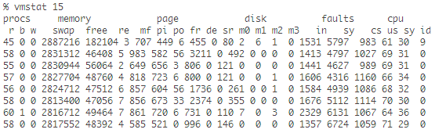
Here we can see an example of insufficient CPU capacity for the executing applications.
Sample 2:
procs memory page disk faults cpu
r b w swap free re mf pi po fr de sr s0 s1 s2 s6 in sy cs us sy id
0 0 0 133136 13400 0 66 14 0 0 0 0 1 7 1 0 194 650 124 3 3 94
0 0 0 3557440 835184 0 22 1 0 0 0 0 0 1 0 0 164 155 151 0 2 98
0 0 0 3557440 835184 0 77 0 0 0 0 0 9 7 1 0 213 287 79 0 9 90
What it means
- Procs (Processors)
  - r means number of runnable processes during the interval. It does not include processes waiting or in I/O.
  - b the number of processes that are blocked waiting for I/O or other event.
  - w is the number of processes that are swapped out. A non zero value means system was swapping.
- memory
  - swap is used swap space.
  - free is availabe free swap space.
- Page
  - pi means 1 kb pages per second that have been paged in.
  - po means 1 kb pages per second that have been paged out.
  - de means that anticipated short term memory shortfall.
- disk
  - s0, s1, s2, s6 number of disk operations per second on each disk drive.
- faults
  - in
  - sy
- cpu
  - cs is .
  - us is percentage of total cpu time spent in user state.
  - sy is total cpu time spent in system state.
  - id is percentage of total CPU time that CPU is idle.

netstat Command (Displays network statistics)
The netstat tool gives statistics on the network subsystem. It can be used to analyze many aspects of the network subsystem, two of which are the TCP/IP kernel module and the interface bandwidth. An overview of both uses is below.
- netstat -a | grep <your_hostname> | wc -l Output

Linux Performance Monitoring

Tool | Most useful tool function
Top | Process activity
Vmstat | System activity, Hardware and system information
uptime, w | Average system load
ps, pstree | Displays the processes
Free | Memory usage
Iostat | Average CPU load, disk activity
Sar | Collect and report system activity
Mpstat | Multiprocessor usage
numastat | NUMA-related statistics
Pmap | Process memory usage
Netstat | Network statistics
Iptraf | Real-time network statistics
Tcpdump, ethereal | Detailed network traffic analysis
Nmon | Collect and report system activity
Strace | System calls
Proc file system | Various kernel statistics
KDE system guard | Real-time systems reporting and graphing
Gnome System Monitor | Real-time systems reporting and graphing

Free Command
The command /bin/free displays information about the total amount of free and used memory (including swap) on the system. It also includes information about the buffers and cache used by the kernel.
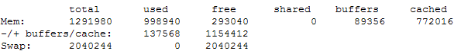
Figure 5 Example Output From the Free Command

When using free, remember the Linux memory architecture and the way the virtual memory manager works. The amount of free memory is of limited use, and the pure utilization statistics of swap are not an indication of a memory bottleneck.

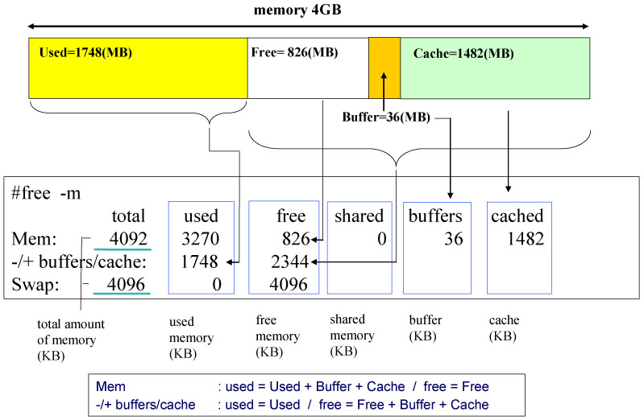

Useful parameters for the free command include:

-b, -k, -m, -g | Display values in bytes, kilobytes, megabytes, and gigabytes
-l | Distinguishes between low and high memory (Refer to 1.2, "Linux memory architecture" on page 11.)
-c <count> | Displays the free output <count> number of times

General Tips

How to see the complete syntax of a command?
<command> -? Or <command -help
Example:
- Solaris/WIN: $iostat -?, $iostat –help

Java Specific command help
Usually for Java non-standard options, enter the command: $java –X
For more information on each option, run the following command:
$java <name of option>:help
For ex., java -Xrunhprof:help

Where do I find detailed help on the command?
Use man pages. "man <command>”

How do I redirect standard out and error of a JVM to a file?
Example:
java -ms32m -mx200m -verbosegc -classpath $CLASSPATH
-Dweblogic.Name=%SERVER_NAME% -Dbea.home="C:\bea"
-Dweblogic.management.username=%WLS_USER%
-Dweblogic.management.password=%WLS_PW%
-Dweblogic.management.server=%ADMIN_URL%
-Dweblogic.ProductionModeEnabled=%STARTMODE%
weblogic.Server>> logfile.txt 2>&1
where
- “>” Redirects standard out to the given file. “>>” appends standard out to the given file.
- 2>&1 redirects the standard error to standard out
Therefore, the “>> logfile.txt 2>&1” options redirect both the standard error and standard output to the given file (logfile.txt in this case).

References

[DANSOLA_01] | Daniel Edwin and David Dagastine, Performance Tools and Tuning Tips for Java Technology-Based Server Applications on the Solaris OS, Nov 2001
[HAINES] | Steven Haines, Solving Common Java EE Performance Problems, APress
[CILIENDO_LIN] | Eduardo Ciliendo and Takechika Kunimasa, Linux Performance and Tuning Guidelines, IBM Redbooks
[GOETZ_03] | Brian Goetz, Java theory and practice: Garbage collection in the HotSpot JVM, Nov 2003
[SUN_TUNING] | http://java.sun.com/performance/reference/whitepapers/tuning.html
[GC_JVM5.0] | Tuning Garbage Collection with the 5.0 Java[tm] Virtual Machine
[SUN_5.0_PER] | http://java.sun.com/performance/reference/whitepapers/5.0_performance.html
 | http://developers.sun.com/mobility/midp/articles/garbage/
 | http://www.informit.com/guides/content.aspx?g=java&seqNum=22
 | http://developers.sun.com/solaris/articles/tuning_solaris.html
 | http://java.sun.com/javase/technologies/hotspot/gc/gc_tuning_6.html
[SUN_VMOPTS] | http://java.sun.com/javase/technologies/hotspot/vmoptions.jsp
[SUN_LEAKS] | http://java.sun.com/javase/6/webnotes/trouble/TSG-VM/html/memleaks.html
[TOOL_DESC] | Detailed Tool Descriptions
[PERF_WIKI] | Performance Wiki
[WLS_10_07] | Weblogic Server Performance & Tuning, March 2007
[GOTTRY_01] | Ken Gottry, Pick Up Performance With Generational Garbage Collection, Nov 2001, JavaWorld
[PRINTEZIS_04] | Tony Printezis, Garbage Collection in the Java HotSpot Virtual Machine, Sept 2004, Retrieved on May 11, 2009, DevX
[HPROF_DOC] | http://java.sun.com/developer/technicalArticles/Programming/HPROF.html
[HAT_DOC] | https://hat.dev.java.net/
[SHIRAZI_PERF] | Jack Shirazi, Java Performance Tuning, 2nd Ed, 2003, O’Reilly, ISBN 0596003773
[JAVA5_TROUB] | Java 5.0, Troubleshooting and Diagnostic Guide, Sun Microsystems, 2007

